**Hello World RESTful Web Service** 

**Application.properties:**

spring.application.name=spring-learn

logging.level.com.cognizant.spring_learn=DEBUG

server.port=8083

**HelloController.java:**

**package** com.cognizant.spring_learn.controller;

**import** org.slf4j.Logger;

**import** org.slf4j.LoggerFactory;

**import** org.springframework.web.bind.annotation.GetMapping;

**import** org.springframework.web.bind.annotation.RestController;

@RestController

**public** **class** HelloController {

**private** **static** **final** Logger ***LOGGER*** = LoggerFactory.*getLogger*(HelloController.**class**);

@GetMapping("/hello")

**public** String sayHello() {

***LOGGER***.info("START - sayHello");

String message = "Hello World!!";

***LOGGER***.info("END - sayHello");

**return** message;

}

}

**SpringLearnApplication.java:**

**package** com.cognizant.spring_learn;

**import** org.springframework.boot.SpringApplication;

**import** org.springframework.boot.autoconfigure.SpringBootApplication;

@SpringBootApplication

**public** **class** SpringLearnApplication {

**public** **static** **void** main(String[] args) {

System.***out***.println("Starting SpringLearnApplication...");

SpringApplication.*run*(SpringLearnApplication.**class**, args);

System.***out***.println("SpringLearnApplication started successfully.");

}

}

**OUTPUT:**

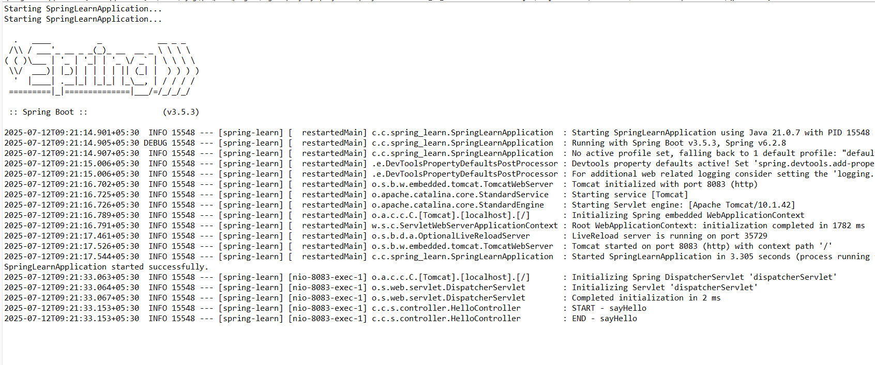

<http://localhost:8083/hello>

